Introduction to Book Keeping, Accounting and Accountancy
he American Institute of Certified Public Accountants(AICPA) defines accounting as an art of recording, classifying, and summarizing the transactions and events that are in monetary terms efficiently and effectively and are interpreting the results. The main aim behind the accounting process is the ascertainment of an organization’s operation’s net results and financial position so that the firm can communicate the same with the interest parties or users of Accounting Information. The nature of Accounting is dynamic and analytical and hence, requires special abilities and skills in an individual to interpret the information better and effectively.
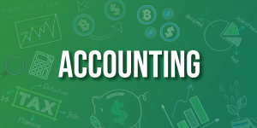
Accountancy is the process of measuring, processing, and recording an organization’s financial and non-financial statements. It has a wider scope than Accounting as it is the route to the Accounting process. Accountancy is responsible for prescribing the accounting conventions, principles, and techniques to be followed by an organization during the accounting process.

Objectives of Accounting
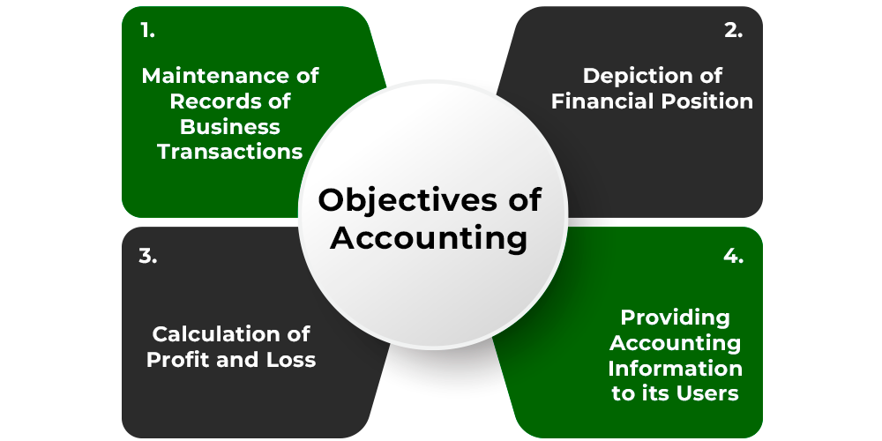
- Maintenance of Records of Business Transactions: No individual can remember every detail regarding the sales, purchases, payments, revenue, receipts, expenses, etc., of an organization. Therefore, a proper, accurate, and regular, systematic recording of business transactions is essential for every organization. Accounting helps an organization in recording and maintaining the records of business transactions.
- Depiction of Financial Position: Another objective of accounting is the ascertainment of an organization’s financial position in the form of its liabilities and assets at the end of each financial year. An organization can depict the financial position for the accounting year with the help of financial statements.
- Calculation of Profit and Loss: The central aim of every organization is to earn and maximize profit. For this, the business owners might need an idea of the net results based on the organizational operations. Therefore, accounting aims at ascertaining the loss sustained and profit earned by an organization during the financial year.
- Providing Accounting Information to its Users: The Accounting information generated by an organization in the form of financial statements, reports, charts, etc., for the accounting year is used by different external and internal users. Accounting provides relevant information about the organization to these users. Some of the users of accounting information are management, employees, investors, creditors, banks, financial institutions. etc.

Advantages of Accounting
- Provide Information about Financial Performance: The process of Accounting provides accurate and factual information regarding the financial performance of an organization during a given financial year. The organizational information includes profit earned, the loss incurred, financial position, and other essential facts required by the different users of accounting information.
- Provide Assistance to Management: The process of accounting helps the management of an organization in effective business planning and decision-making for the attainment of the organizational objectives. The management can do so with the help of the financial information provided by the accounting process.
- Helps in Raising Loans: For the survival, success, and growth of an organization, it needs finance. For this purpose, an organization can easily raise loans from different Financial Institutions and Banks based on the information provided by the accounting process in the form of financial statements and reports.
- Facilitates Comparative Study: As an organization prepares and maintains systematic financial records, it can effectively perform a comparative study. An organization can compare its current year’s performance with the previous years’ performance or with the performance of the competitors.

Limitations of Accounting
- Accounting Information may be Unrealistic: As the records of an organization are maintained on the basis of the accounting principles, conventions, and concepts, there is a possibility that the information provided by the organization may be unrealistic.
- Possibility of Window Dressing of the Financial Position: Organizations may present wrong and over-the-top information about their financial position by manipulating the books of accounts to attract people, investors, and different users. In these cases, the financial statements do not provide a true picture of the organization.
- Does not Consider the Qualitative Elements: The Accounting process only considers the monetary values or transactions and ignores the qualitative aspects of an organization.
- Accounting Records are not Fully Correct: An organization records its transactions in the books of accounts based on the sources like purchase invoices, sales invoices, cash receipts, bills, etc. If there is a mistake in any of these sources, the books of accounts will not show accurate information regarding the organization.

Accounting Information
It is defined as the information provided by an organization in its financial statements for different internal and external users. An organization prepares the accounting information with the help of the Book-keeping process. The process helps the different users in understanding the financial position and profitability of the organization and make financial decisions accordingly.

Qualitative Characteristics of Accounting Information:
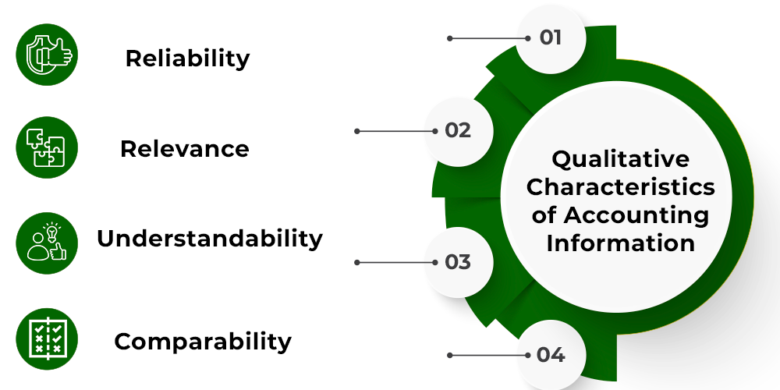
- Reliability: It is the ability of a user to depend on the information provided by an organization. Accounting information can be stated as reliable if it is free from errors any kind of personal bias. In other words, the information provided by an organization must be verifiable and based on proper facts.
- Relevance: It is the ability of information to meet the users’ needs and help them make important decisions. The information provided by the organization must be available to the users on time and hence, help them in forecasting.
- Understandability: It means presenting the accounting information of an organization in a way that the users can understand it in the same sense as the organization wants to convey. With proper understandability only, an organization can communicate effectively with the different users of accounting information.
- Comparability: Relevance and Reliability of the accounting information is not enough; it should also be comparable. It means that the organization should use the same measures of reporting and accounting principles, so the users can effectively compare the current year’s reports with the previous years’.

Users of Accounting Information:
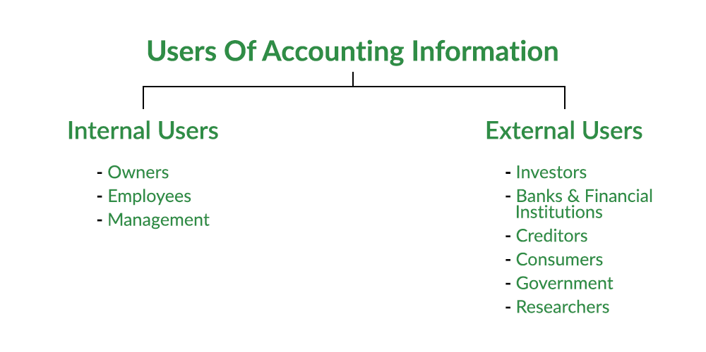

1. Internal Users
- Owners: The owners of an organization contribute their savings as capital in the business. Therefore, the owners are exposed to the risks involved with the business and, hence, want to ensure the safety of their capital.
- Employees: The employees of an organization are interested in the accounting information to determine the ability of the firm to pay their bonuses and salary.
- Management: The management of an organization has to make various decisions for its success, growth, and accomplishment of goals. For this, the management uses the accounting information to make certain essential decisions.

2. External Users
- Investors: Investors are the people or groups of people who invest their money in organizations. These investors want to know about the earning capacity of the organization so they can decide the safety and risk level of investing in an organization.
- Banks and Financial Institutions: The banks and financial institutions provide loans to different businesses. They use the accounting information to ensure the repayment of their loan.
- Creditors: Creditors provide an organization with goods on credit. They take the help of accounting information to understand the credibility and financial soundness of the organization to pay their money.
- Consumers: Consumers use the accounting information of an organization to establish good accounting control over the business that can reduce the production cost.
- Government: The Government uses accounting information to determine and assess the tax liability of an organization.
- Researchers: Researchers use the accounting information of an organization to complete their research work and provide actual facts and figures in their work.

